**Assignment 2 – Game of 15**

**Activity Diagram:**

The diagram below describes the activities involved in the game and the control flow.

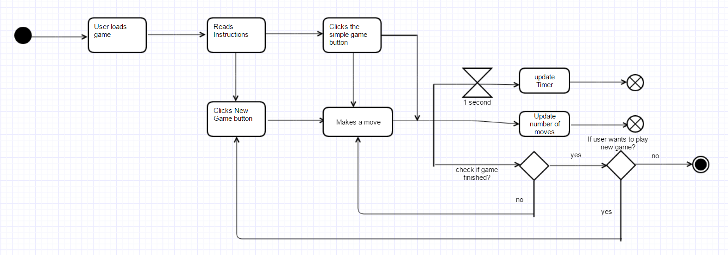

**Problem:**

The 15 puzzle is an interesting game where the numbers 1 to 15 are displayed as tiles, out of order. The numbers must be rearranged by swapping an empty tile. So, when the page loads, a shuffled board is displayed to the user and the timer starts running. As the user starts swapping tiles with the numbers, the moves made by the user must be counted. A New Game and Simple Game button is provided to the user which allows the user to shuffle the board and play a game with one tile out of place, respectively. The no of moves and the time elapsed is reset for every new game.

The implementation of the 15 puzzle in javascript can be divided into the following sub tasks:

1. Creating a html with a table and 16 cells
2. Assign an array with the numbers 1 to 15 and an empty element “ “. And keeping track of the empty element position: emptyCell
3. Shuffling the array using the math.random method.
4. Assigning each element to the cell using its id.
5. Adding an event listener to each cell in the table, and checking if the cell calling the event listener is one of its neighbors. If the condition is true, then the empty cell is swapped with the current cell and so on.
6. After every swap, the no of moves is incremented and the array of numbers in the table is checked if it is in order, and the user is prompted if he wants to play a new game.
7. The new game button shuffles the numbers on the board and the simple game displays with just one tile out of order. The timer and the moves counter is reset.

I used the Agile methodology to develop the program, by executing the code after each step and checking for errors.